ADTA 5900/5750.501: Applied Natural Language Processing
Assignment 3

PART I: Midterm Assessment Information (5 Points)
Answer the following questions:
- How many sections (or parts) are there for the midterm assessment?
Answer: The midterm assessment consists of three parts: PART I, II, and III. PART I & II are take-home assignments.
- Which sections are take-home assignments that the student will work on them at home?
Answer: PART I & II are take-home assignments.
- When will MIDTERM ASSESSMENT: PART I & II be assigned?
Answer: Assigned on Monday 10/07/2024 (WEEK 8).
- When will MIDTERM ASSESSMENT: PART I & II be due?
Answer: Due by 11:00 PM on Wednesday 10/16/2024 (WEEK 9)
- Which sections will the student take in-person in class?
Answer: Part III will be an in-class assignment.
- When will the student take MIDTERM ASSESSMENT: PART III in-person in class?
Answer: On Monday during class hours (5.30 PM on 10/07/2024)
PART II: Access and Read Codelab Tutorials on Dialogflow CX (15 Points)
Answer: I have read the Codelab tutorials on DIalogflow CX.
https://codelabs.developers.google.com/codelabs/dialogflow-cx-retail-agent#0
PART III: Develop Conversational AI System for G-Records (70 Points)
TO-DO #1
- Following the steps discussed in the tutorial, create a new virtual retail agent for G-Records.
- Next, set up the environment by creating a new project for the virtual retail agent.
Answer: I have created a new virtual agent “grecords-retailer”. The below screenshot displays the same.
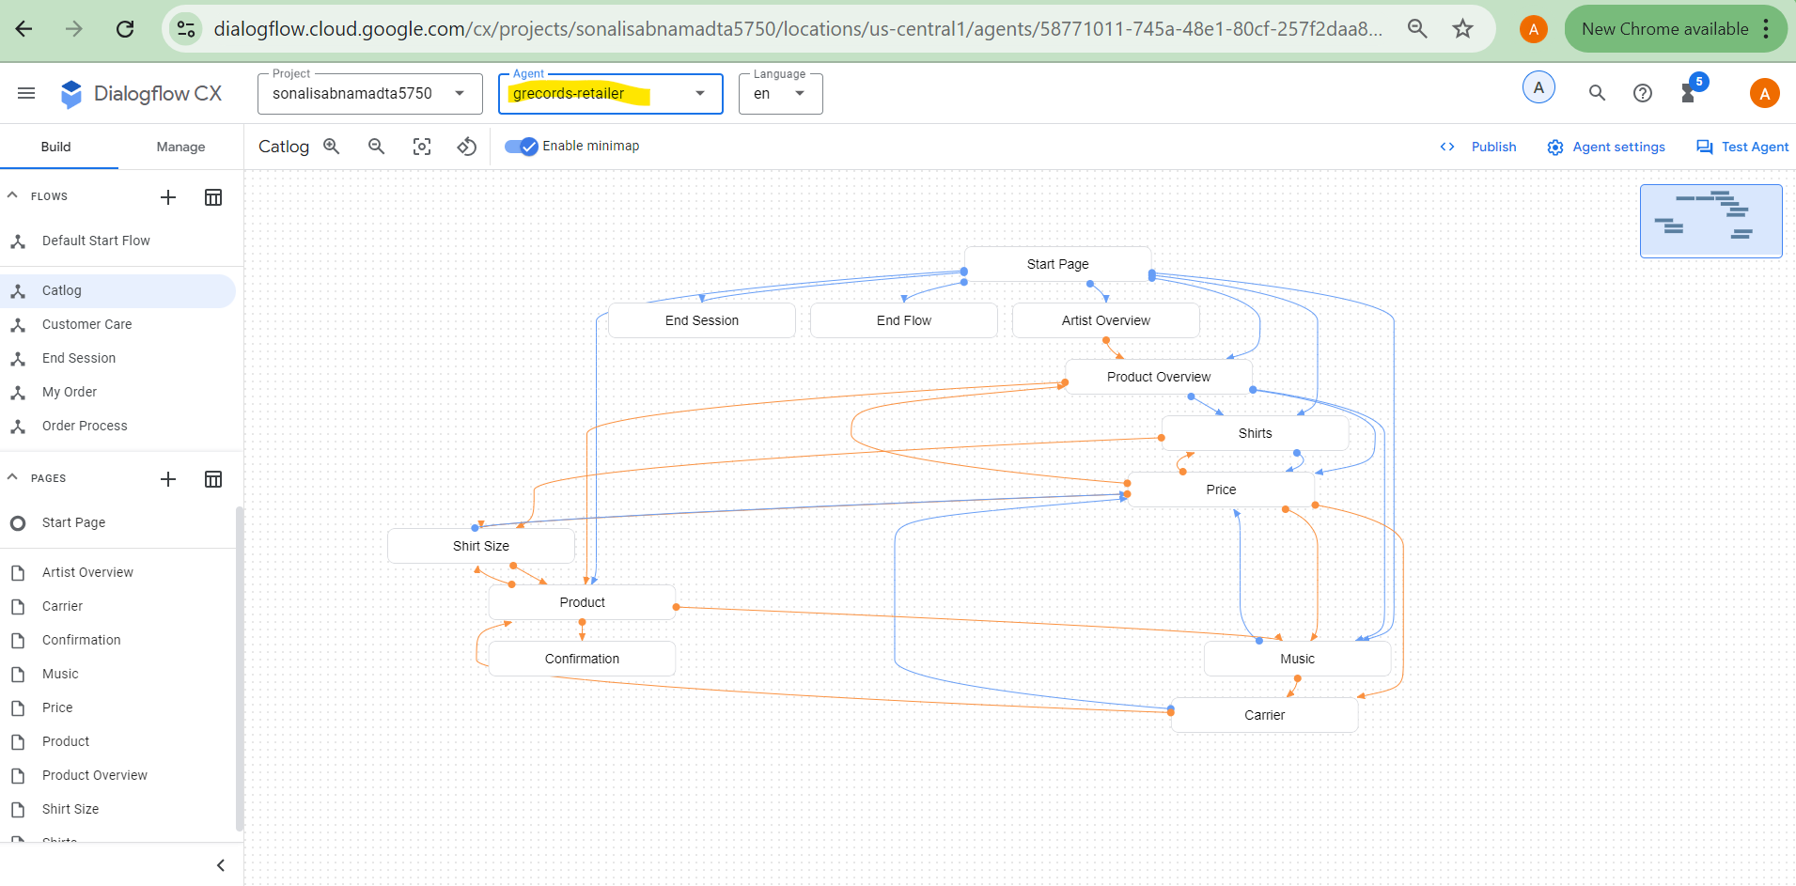
TO-DO #2
- Next, complete the steps to add the flows to the conversational AI system.
- After completing all the steps, capture the screenshot that shows all the dialog flows that have been created.
Answer: The below mentioned steps were taken to create the flows.
- Select “Build” tab and click the “+” beside the “FLOWS”.
- Enter the name of the Flow and click the tick mark.
- The flow gets created.
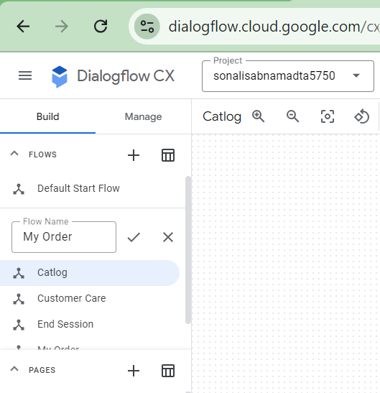
Below screenshot shows the Flows created.
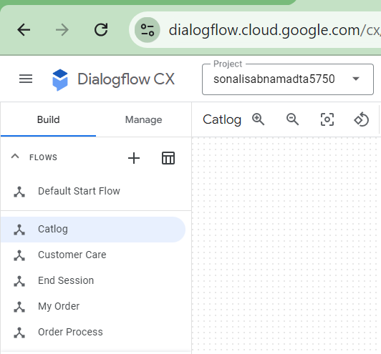
TO-DO #3
- Next, complete the steps to define entity types and entities for the conversational AI system.
  - Use MS Word or PowerPoint to create diagrams that contain the figures representing the entities with their entity type.
- After completing all the steps, capture the screenshot that shows all the entities and their entity types that have been created.
Answer:
The below listed entity types and entities are defined for the conversational AI system.
Entity: Artist
- The Google Dolls (with synonym: Google Dolls)
- The Goo Fighters (with synonym: Goo Fighters)
- G's N' Roses (with synonym: Gs and Roses)
- Alice Googler
Entity: Merch
- T-shirt
- Longsleeve (with synonym: Longsleeve shirt)
- Tour Movie
- Digital Album (with synonym: MP3 Album, MP3)
- CD (with synonyms Disc, Physical CD)
Entity: Album
- Live
- Greatest Hits (with synonym: Hits)
Entity: ShirtSize
- XS (with synonym: Extra Small)
- S (with synonym: Small)
- M (with synonym: Medium)
- L (with synonym: Large)
- XL (with synonym: Extra Large)
- 2XL (with synonym: Extra Extra Large)
- 3XL
Entity: OrderNumber
- Regexp entities
- Entity: [A-Z]{4}[0-9]{3}
The below diagrams show the entities:
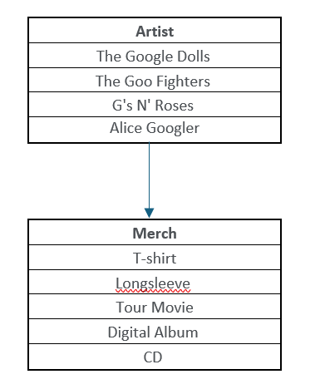
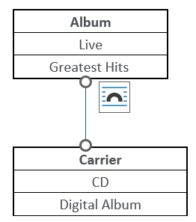
OrderNumber
[A-Z]{4}[0-9]{3}

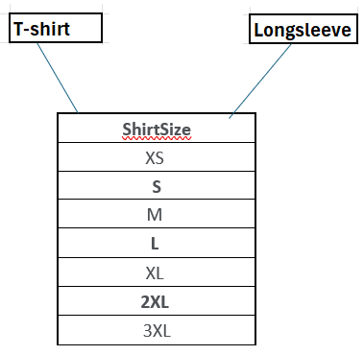
The below steps are performed to create an entity successfully.
- Select “Manage” tab and click on the “Entity types” and click on “Create”.
- The below screen appears.
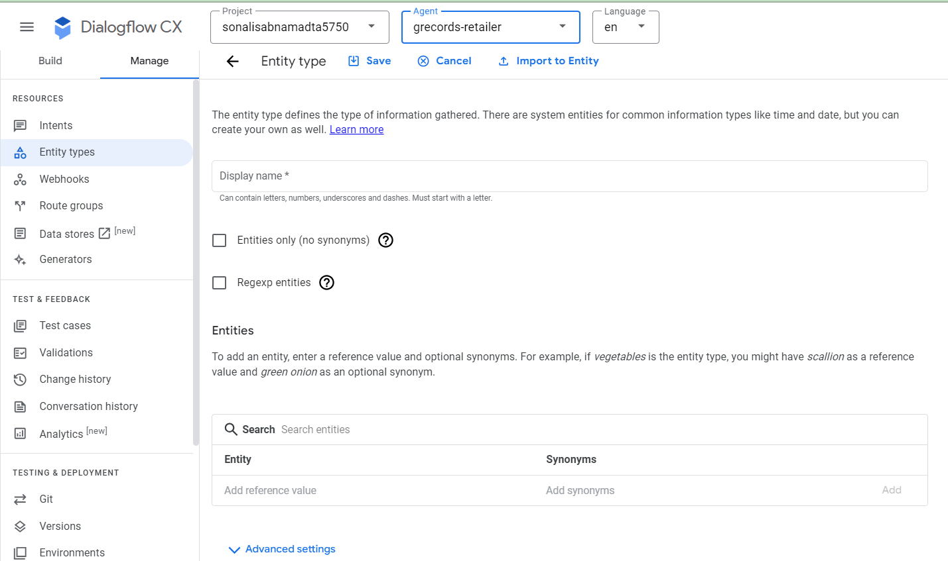
- Fill in the details and click on "Save”.
The below screenshot shows the entity Artist.
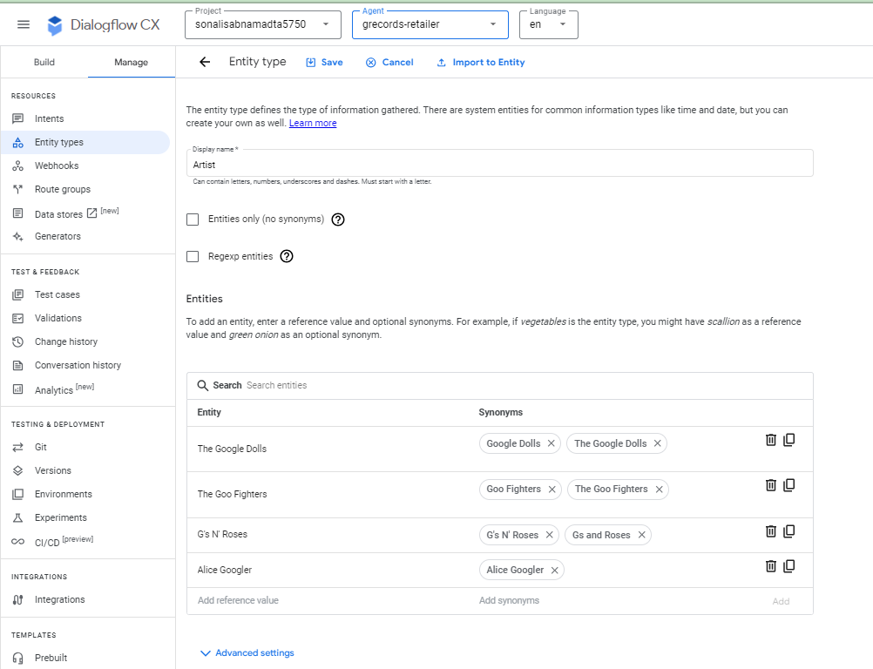
The below screenshot shows the entity Album.
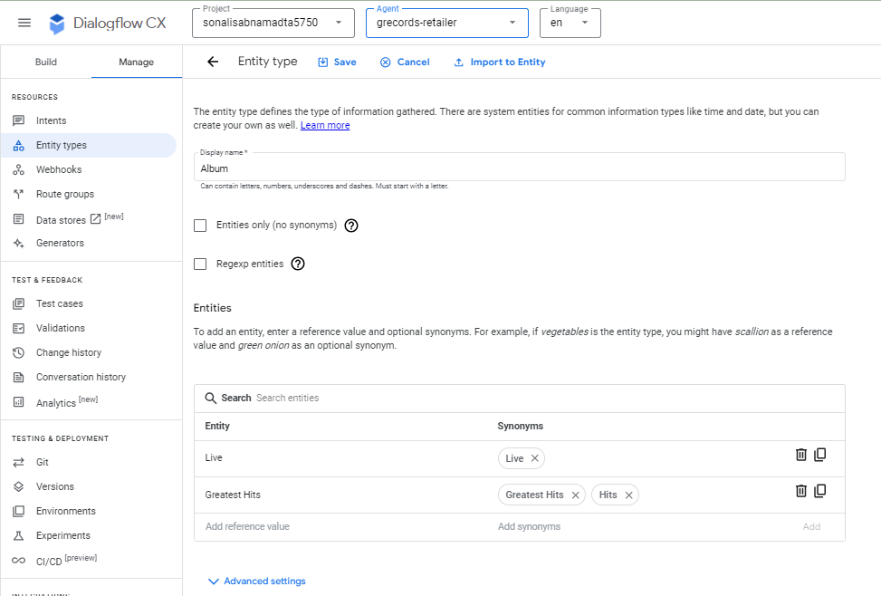
The below screenshot shows the entity ShirtSize.
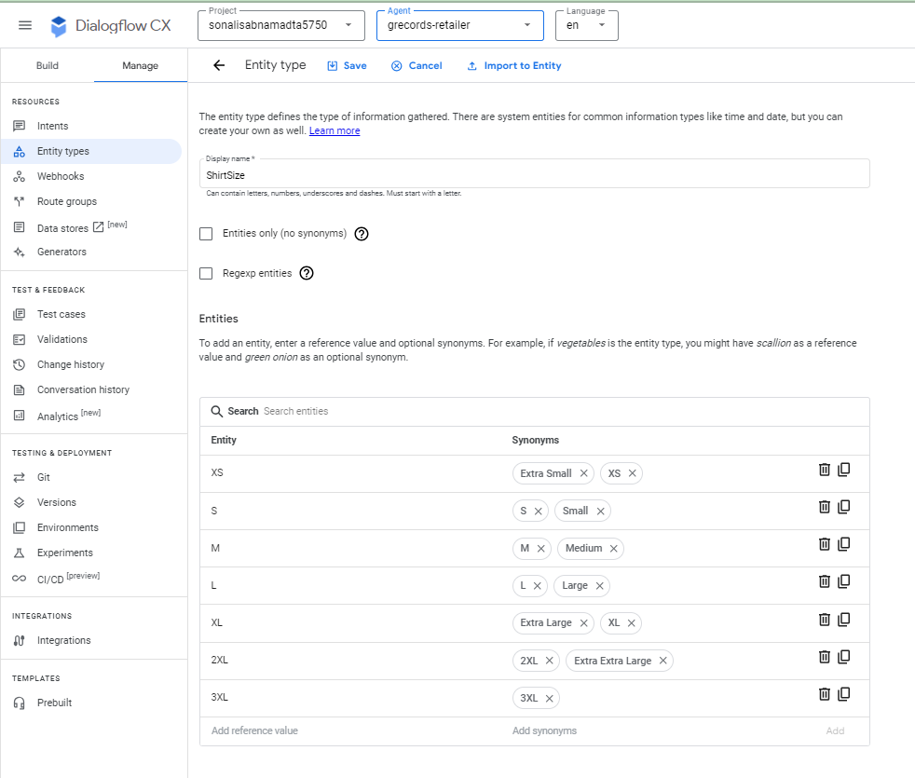
The below screenshot shows the entity Merch.
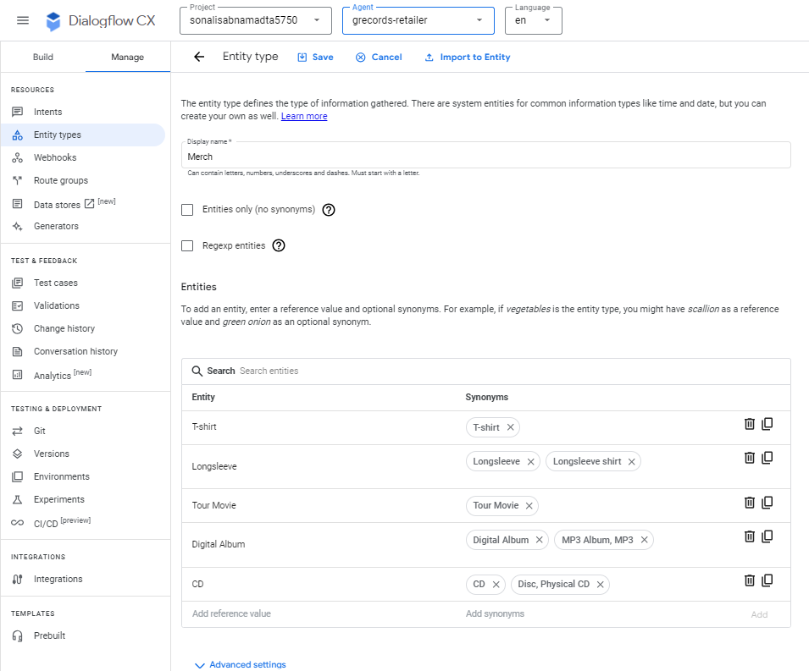
The below screenshot shows the entity OrderNumber.
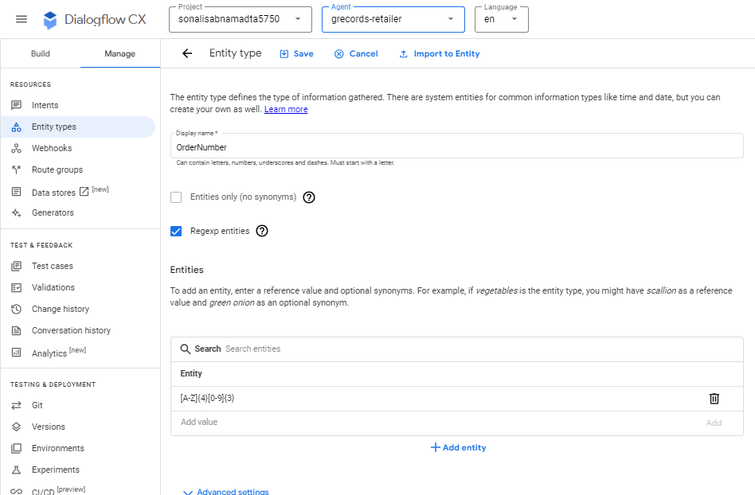

The below screenshot shows the entity types successfully created.
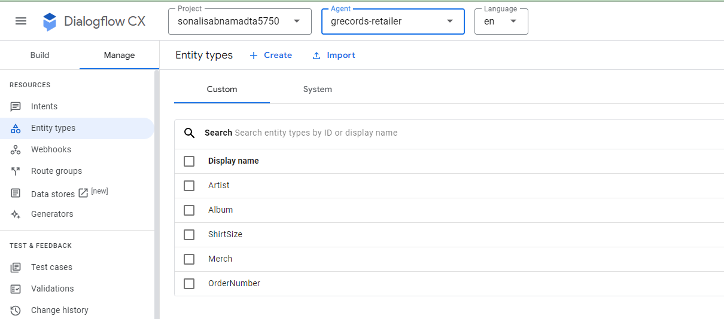

TO-DO #4
- Finally, complete the steps to add the intents for the conversation AI system.
- After completing all the steps, capture the screenshot that shows the list of all intents that have been added for the system.
Answer:
The below steps were performed to create an intent.
- Click on “Manage” and select “Intent”.
- Click on “Create”. The below screen appears.
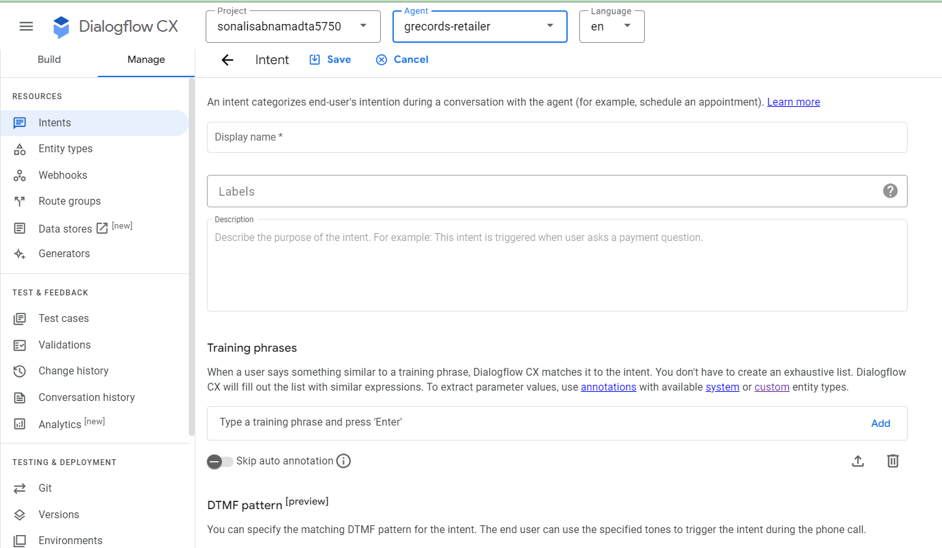
- Enter Display Name, Description and training phrases.
- Click on Save.
- The below screenshot shows intent redirect.home
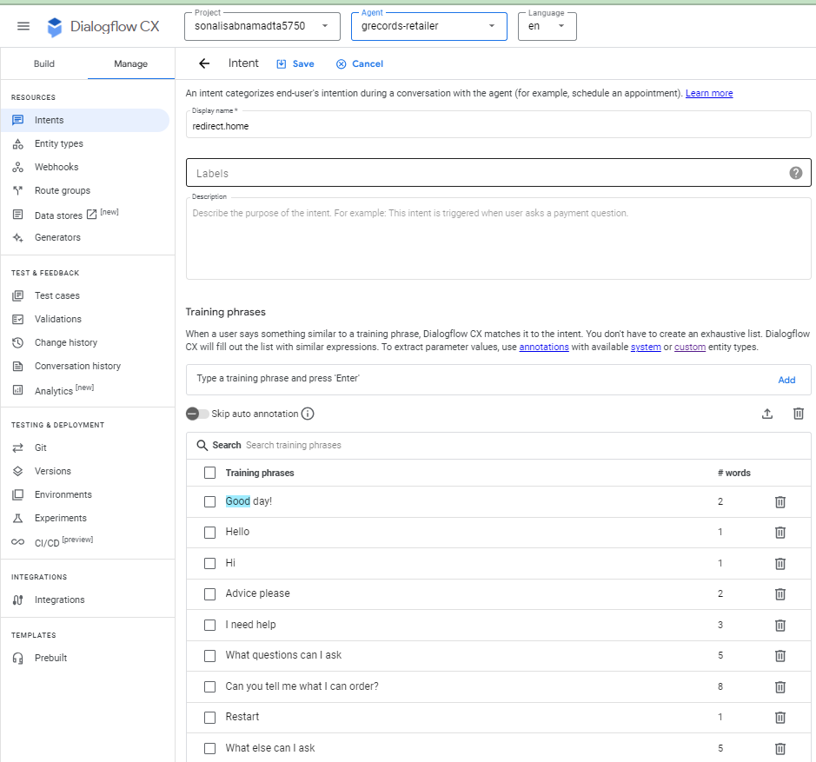
The below screenshot shows the list of all the intents created successfully.
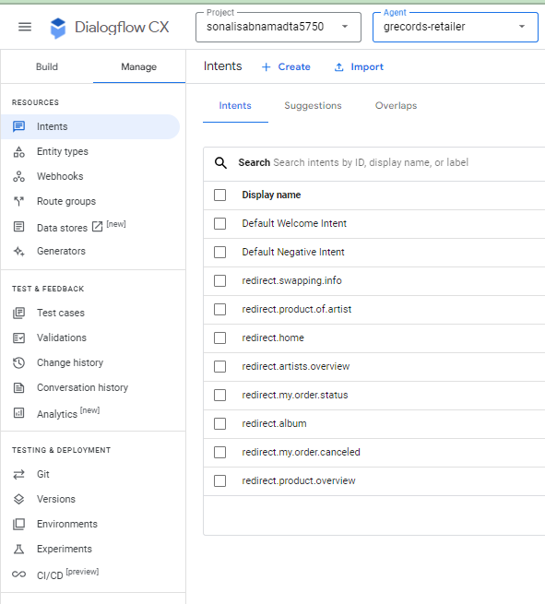
TO-DO #5
• Write a report for each above task (TO-DO 1 – 4) with details about what has been done at each step, illustrated with the screenshots taken while working on each task.
Answer: Report for TO-DO 1-4 is detailed below.
Introduction: As part of this assignment, we are trying to build some parts of a chatbot using DialogFLow CX from Google. This chatbot will have components like
- Flows
- Entity Types
- Intents
In this report, we will be discussing about each of the component and the steps involved in creating them.
Step 1: Environment Setup
Prerequisite: a valid google account and access to google cloud.
It is a virtual agent capable to handle the simultaneous conversations with users. It can understand details of human language as it is a natural language understanding module.
- Click on “Create new project” and fill in the details as shown in the below screenshot.
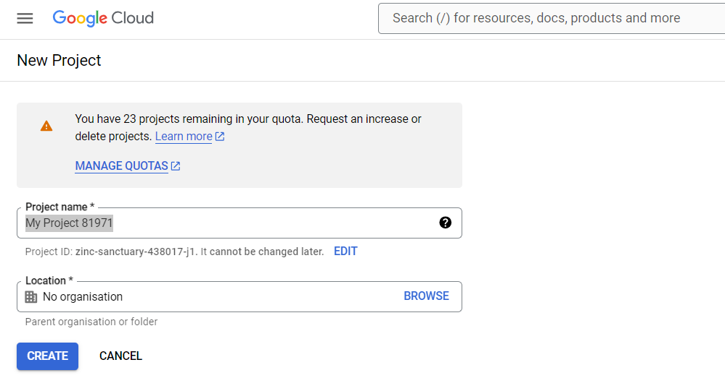
- Click on “CREATE” once details are filled.
- The below screenshot shows the project successfully created.
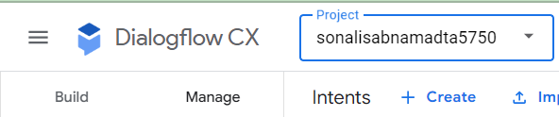
- Click on “Create new Agent” and select “Build your own”.
- The below screen appears.
- Fill in the details and click on “Create”
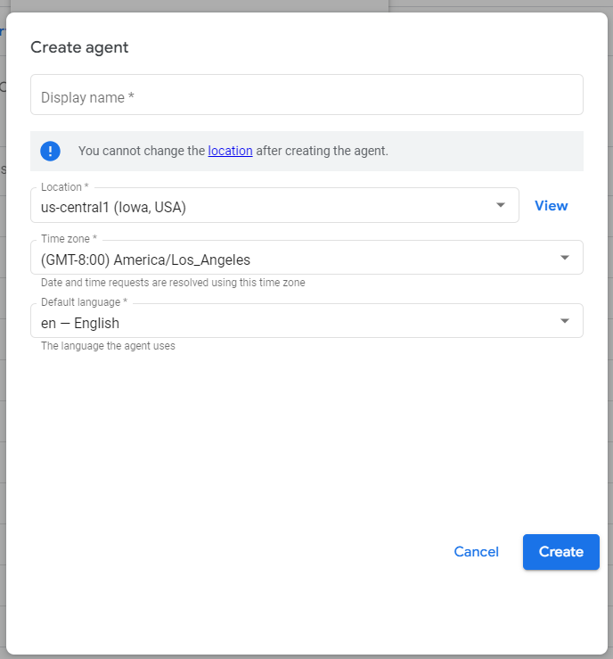

With the project and agent, the environment setup is complete. In the next steps we will be discussing about the components of the chatbot.
Step 2: Creating Flows for the Conversational AI system
Prerequisite: The environment setup should be complete.
A complex conversation can have many topics, a flow is used to define such topics and like “customer details”, “order confirmation”,” payment options” etc. In this case we are going to have five flows.
Follow the below steps to create Flow
- In the build tab lick on the “+” beside Flow and select “Create Flow”.
- The below screen appears. Write the name of the flow and click on the tick mark.

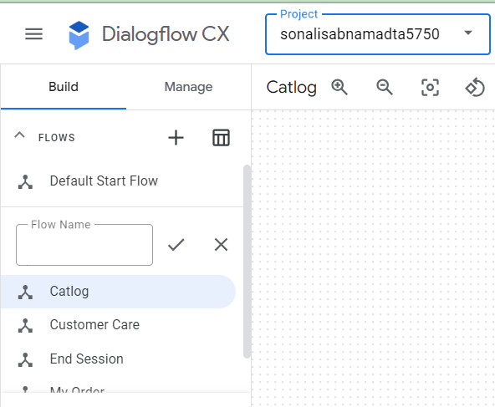
- Repeat the same to create the other flows.
- The below screenshot shows the Flows successfully created.
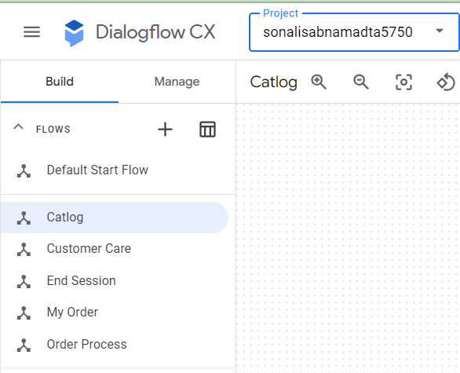
Step 3: Defining and Creating Entity Types for Conversational AI system
Prerequisite: The environment setup should be complete; the flows should be created.
The data extraction from the user input is controlled based on Entity Types. System Entities such as Date, time, email address etc are predefined by DialogFlow CX. We can define our custom entities such as Artist or Merch for placing order with the grecords-retailer agent. The entity types are designed before we create them.
Note: Refer TO-DO 3 for the design of the entities.
The below steps were performed to create the custom entity types.
- In the “Manage” tab select “Entity Type” and click on “Create.
- The below screen is displayed.
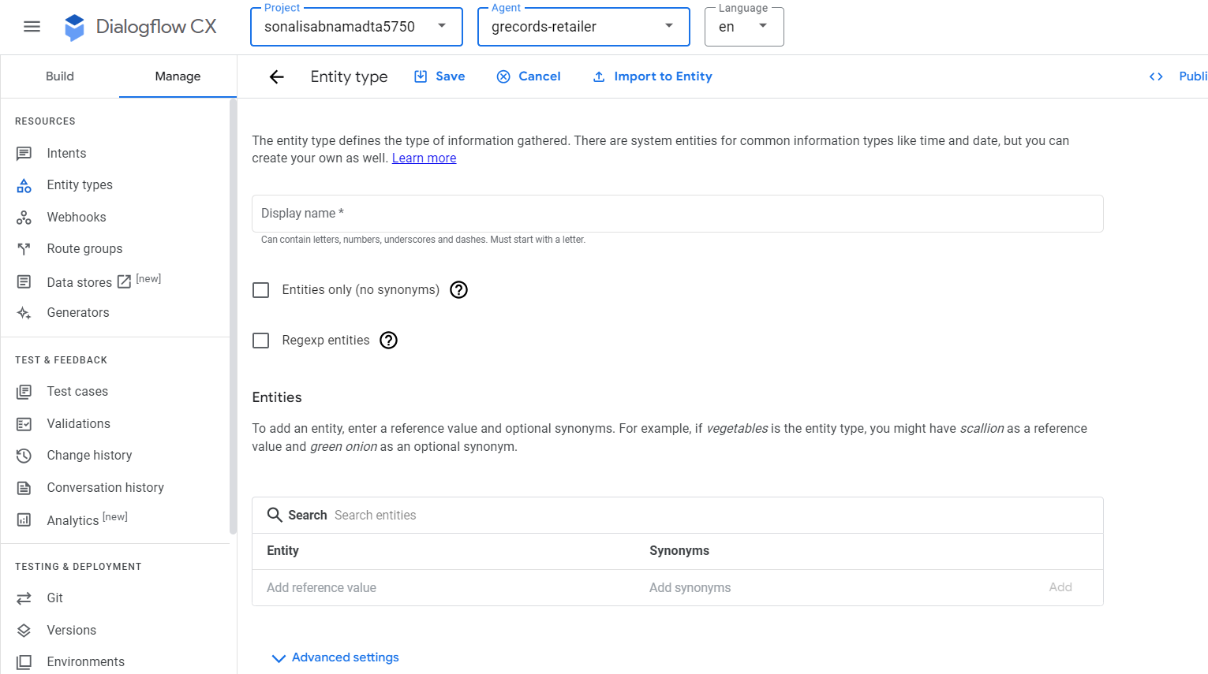
- Fill in the details and click on “Save”.
- Repeat the steps to create all the Entity Types.
- The below screenshot shows the entity types created successfully.
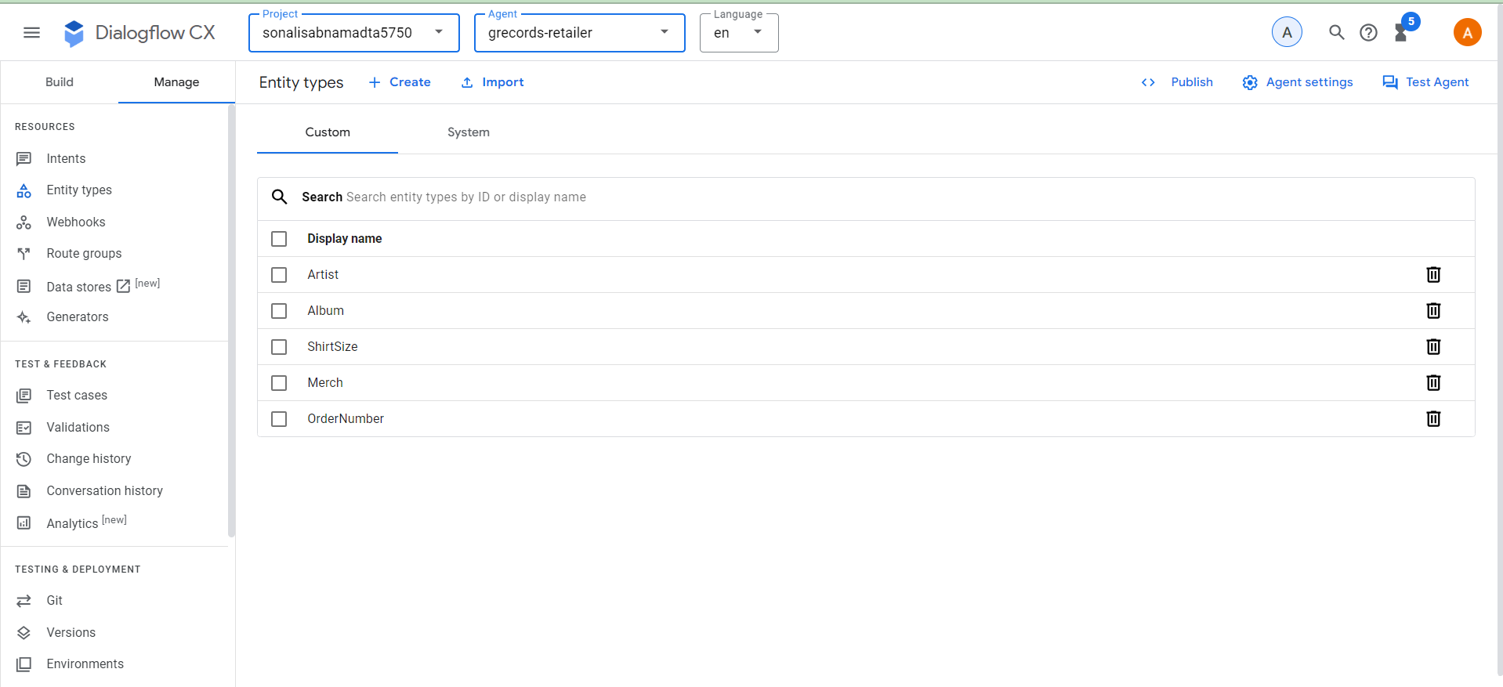
Step 4: Adding the intents for the conversation AI system
Prerequisite: Step 1, 2 and 3 should be complete.
The user’s intention for a conversation turn can be categorized by an Intent.
Intents in Dialogflow CX only contain training phrases and therefore are reusable. It no longer controls the conversation.
The steps of creating intents is shown below.
- Click on “Manage” “Intents” and select “Create”.
- The below screen gets displayed.
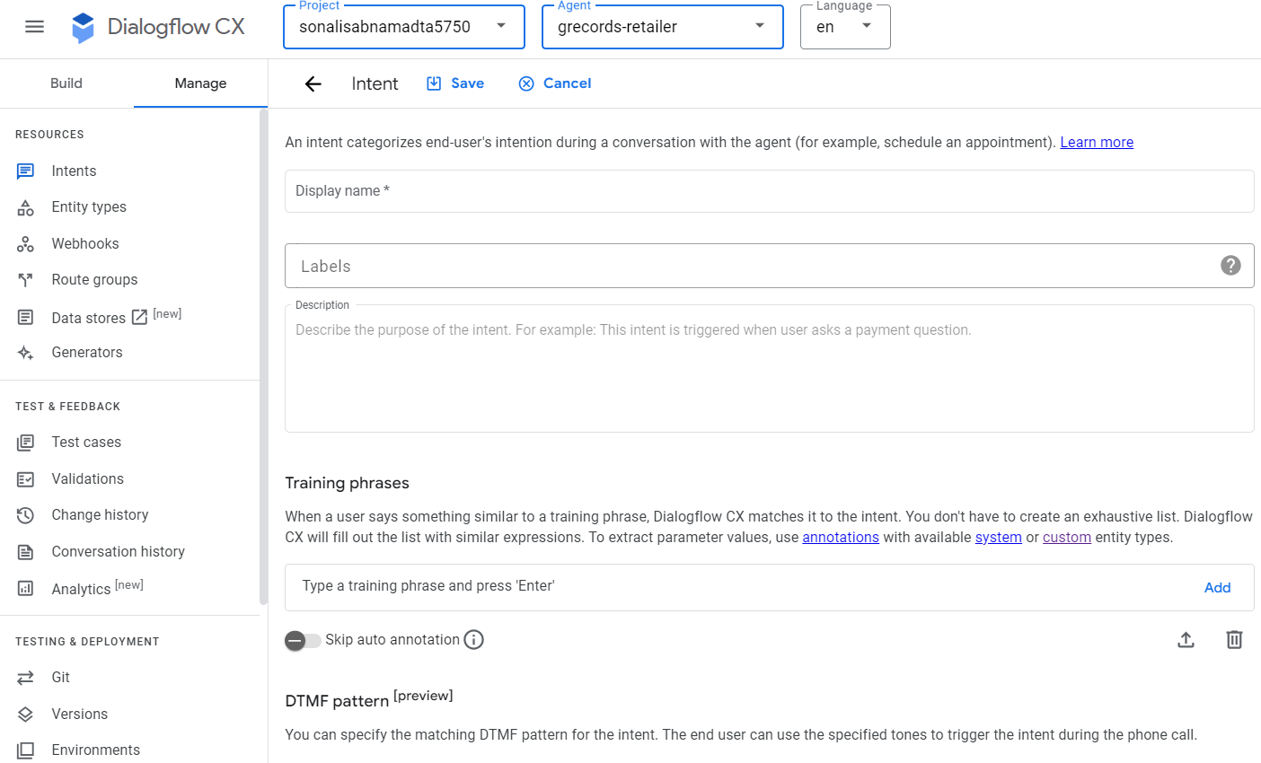
- Enter the Display name, description and training phrases.
- Click on Save.
- Repeat the steps for all the intents.
- The below screenshot shows the intents created successfully.
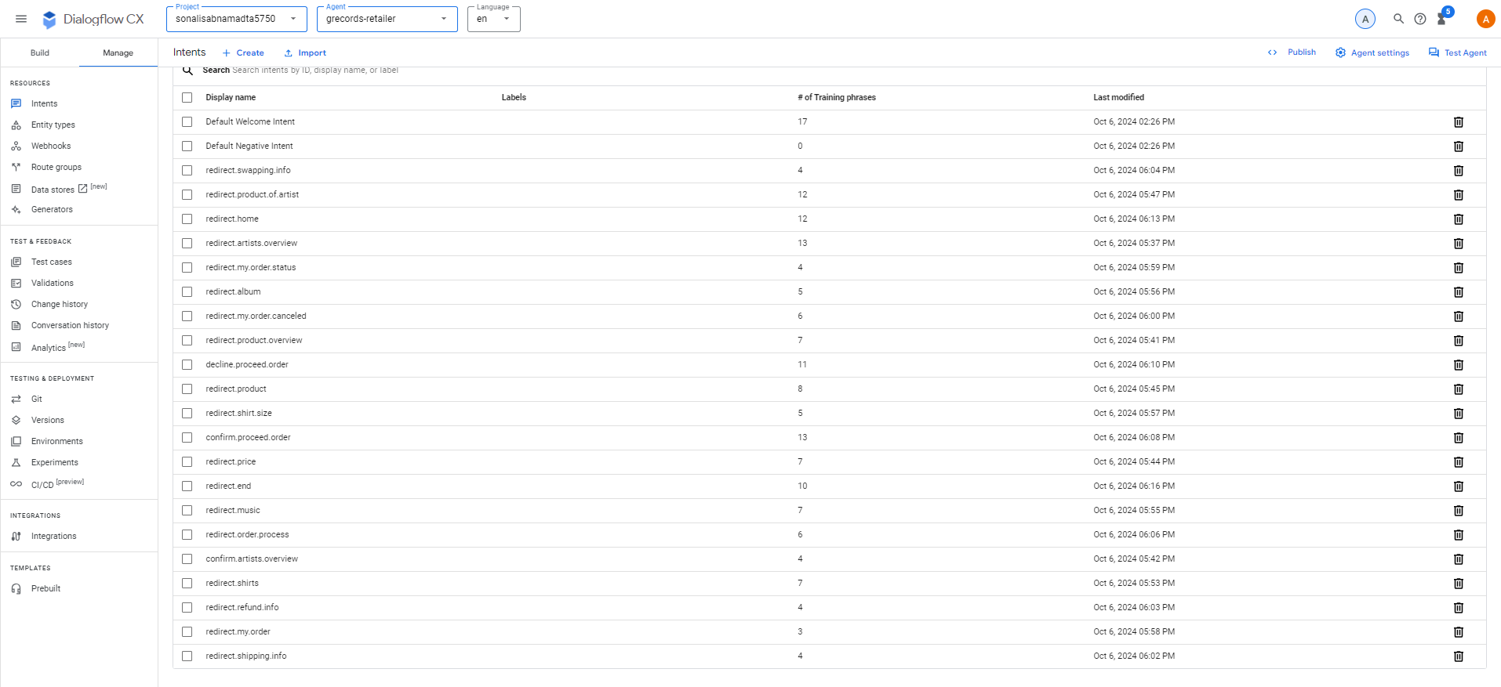
Conclusion: In this report we have successfully detailed the components of the conversational AI system. We have also discussed the steps to create each component and the screenshots.

PART IV: Teamwork Evaluation (10 Points)
- What group do you belong to? (Provide the group number)
Answer: Group 6
- Who are the members of your group?
Answer: Below is the list of members for group 6:
- Paladugu, Sheba Rani
- Shah, Rinal
- Sabnam, Sonali
- Xiong, Tao
- Anne, Rajesh
- Have the members organized any meeting (ONLINE or IN-PERSON) to see each other?
Answer: Yes, we had an online meeting on Saturday (10/05/2024).
- If YES to #3, which members, including the student himself/herself, showed up in the meeting?
Answer: All the members showed up in the meeting.
Paladugu, Sheba Rani
Shah, Rinal
Sabnam, Sonali
Xiong, Tao
Anne, Rajesh
- Have the members worked with each other on any class assignments?
Answer: Yes. We have discussed the assignments and exchanged ideas.
- If YES to #5, do all the members make good efforts to actively participate in the group work?
Answer: Yes
- If NO to #5, do you have any opinions to share about the group?
Answer: All team members are contributing their ideas. We had an engaging discussion.

